**STUDENT INDUSTRIAL WORK EXPERIENCE SCHEME (SIWES)**

**(APRIL 3RD, 2023- AUGUST 31ST, 2023)**

**AT**

**ERNST AND YOUNG(EY)**

**10TH AND 13TH FLOOR, UBA HOUSE 57 MARINA ROAD LAGOS**



**A TECHNICAL REPORT**

***Delivered by:***

**ALADEGBOLA OLUWATOMILOLA LAUGHTER**

**(20CH028152)**

**SUBMITTED TO**

**THE DEPARTMENT OF COMPUTER AND INFORMATION SCIENCES,**

**COVENANT UNIVERSITY**

**IN PARTIAL FULFILLMENT FOR THE AWARD OF THE DEGREE OF BACHELOR OF SCIENCE (B.Sc.), MANAGEMENT INFORMATION SYSTEM,**

**COVENANT UNIVERSITY, OTA, OGUN STATE, NIGERIA**



**OCTOBER, 2023**

# **DEDICATION**

I dedicate this report to God Almighty my support, the one who strengthened me all through this internship, gave me hope, gave me the motivation daily, and surrounded me with encouraging and inspiring people every day throughout my internship.

I would also like to dedicate this report to my parents Mr. and Mrs. Aladegbola for their support, patience, and words of encouragement during my period of waiting and even after I got the placement, for their love and for being a source of physical strength throughout my internship period.

To my school Covenant University, I dedicate this report for their help, training, for providing various platforms for counsel, and advice before the internship began which helped me take advantage of the various opportunities and have a wonderful experience and made it easier to adapt to the work culture and experience.

I dedicate this report to the Talent team at EY for recognizing me, accepting me into the family, and allowing me to be a part of the vision of building a better working world by being a better me- to grow in skills, network, maturity, and embrace the importance of team.

To my amazing team- the whole EY technology team Mr. Ismail Muftau, Mr. Felix Damissah, Mr. Rotimi Afolabi, Wisdom Udeh, Chukwunonso Odega, and Emmanuella Anatogu I dedicate this report to them for being supportive, for their words of encouragement, for their advice and for helping me realize that there is so much more I can do by recognizing the little things I do and appreciating me and for being a family I could lean on all through my internship

# **ACKNOWLEDGMENT**

I am grateful to God for the grace to get a placement, start my internship, and end it successfully for the grace to scale through the hard times and not give up, for the people I got to meet and work with, and for the experience.

A big thank you to EY Global and Nigeria for making this opportunity available to me and other interns, their amazing work culture and lifestyle, and the opportunities they made available to grow in skills and other areas throughout my internship. I learned a lot from networking, building relationships and even being a better version of myself in my career.

I would like to appreciate the Talent team for making various sessions available even for the interns from anchor day to end of the month intern’s roundtable to providing mandatory learnings to help me prepare well to be an impactful team member, for their amazing work culture and making sure everyone feels welcome into their team and the company at large.

I also want to acknowledge and appreciate other members of the firm both client-facing and non-client-facing for being people I could look up to, and for their advice, support, and welcoming behaviour throughout my internship.

I am grateful to my supervisors for their patience, supervision, advice, and counsel throughout my internship program. I couldn’t have wished for better supervisors.

I want to thank my fellow interns who I worked with specifically in my unit who I consider my family- my brother and sister for a fun experience, for guiding me, and for the amazing memories we made together. I am forever grateful to have found them as we have formed a strong bond even within a short period.

I wish to acknowledge my parents Mr and Mrs Aladegbola for driving me daily and stepping out of their comfort zone to ensure that I got to work on time throughout my internship period. I am grateful to them for their support and counsel when things were tough.

And to every member of EY who contributed to my growth career-wise, emotionally, and in other areas all through my internship period I am grateful. I am sincerely grateful for the various ways they have impacted me.

# **ABSTRACT**

This report is a summary of my internship experience with Ernst and Young (EY) on the 10th and 13th floor, UBA House 57 Marina Rd. Lagos which commenced on 3rd April 2023 and ended on 31st August 2023 (22 weeks). It is an overview of the tasks I performed, work done, challenges I faced, contributions, and my experience at the company.

The report contains a detailed description of the company, my engagements in the company, skills I gained both technical and nontechnical skills, resources I made use of, the facilities available in the company, my experience, conclusion, and recommendation.

During my internship, I was exposed to various tools specific to the organization which allowed me to provide support and solutions to issues when they arose. I made use of some of the resources available to build skills even those relating to the career I wish to pursue later in the future which made the entire experience worthwhile.

**Table of Contents**

**DEDICATION** i

**ACKNOWLEDGMENT** ii

**ABSTRACT** iv

**CHAPTER ONE** - 1 -

**1.1 ABOUT STUDENT INDUSTRIAL WORK EXPERIENCE (SIWES)** - 1 -

**1.2. RECRUITMENT PROCESS AND ACCEPTANCE.** - 2 -

**1.3. INFORMATION CONCERNING THE COMPANY OF ENGAGEMENT** - 6 -

**1.3.1. ERNST AND YOUNG** - 6 -

**1.3.2 PURPOSE- “WHY?”** - 8 -

**1.3.3 AMBITION- “WHAT?”** - 8 -

**1.3.4 VALUES- “WHO”** - 9 -

**1.3.4 ORGANOGRAM** - 11 -

**1.3.6 COMPANY SERVICES** - 14 -

**1.3.7. INTERNSHIP POLICY** - 14 -

**1.4. SUBMISSION OF NECESSARY LETTERS** - 15 -

**1.4.1 SUBMISSION OF ACCEPTANCE LETTER TO COVENANT UNIVERSITY** - 15 -

**1.4.2 SUBMISSION OF STUDENTS COMMENCEMENT OF ATTACHMENT FORM(SCAF) TO INDUSTRIAL TRAINING FUND OFFICE** - 15 -

**1.5. COMMENCEMENT OF INTERNSHIP** - 16 -

**CHAPTER TWO** - 18 -

**2.1 FACILITIES AVAILABLE AT ERNST AND YOUNG NIGERIA** - 18 -

**2.2** **QUALITY OF WORK FROM COMPANY-BASED SUPERVISOR** - 30 -

**2.3 KNOWLEDGE GAINED WITHIN PERIOD OF INTERNSHIP** - 30 -

**2.3.1 WORK DONE AND KNOWLEDGE GAINED** - 31 -

**2.3.2 TECHNICAL SKILLS GAINED** - 33 -

**2.3.3 SOFT SKILLS GAINED** - 34 -

**2.3.4 TRAININGS AND CERTIFICATIONS COMPLETED** - 35 -

**CHAPTER THREE:** - 36 -

**3.1 APPLICATION OF KNOWLEDGE GAINED** - 36 -

**3.1.1 APPLICATION OF KNOWLEDGE GAINED TO THE FIELD OF STUDY** - 36 -

**3.1.2 APPLICATION OF KNOWLEDGE GAINED TO EY’S GOALS** - 36 -

**3.1.3 APPLICATION OF KNOWLEDGE GAINED IN THE LARGER SOCIETY.** - 36 -

**3.1.4 CORROBORATION/NEGATION WITH KNOWLEDGE ON CAMPUS** - 37 -

**3.1.5 WORK CULTURE IN THE ORGANIZATION AND ITS IMPORTANCE IN ITS GOAL ATTAINMENT AND CULTURE SHOCK** - 38 -

**3.2 CHALLENGES FACED.** - 40 -

**3.3. PROJECT IDENTIFIED FOR THE STUDY** - 42 -

**CHAPTER FOUR:** - 45 -

**4.1. CONCLUSIONS** - 45 -

**4.2. OBSERVATIONS** - 45 -

**4.3. RECOMMENDATIONS** - 47 -

**LIST OF FIGURES**

**Figure 1.1: INVITE TO ASSESSMENT PARTICIPATION - 4 -**

**Figure 1.2: ERNST AND YOUNG’S ACCEPTANCE LETTER - 6 -**

**Figure 1.3: ERNST AND YOUNG LOGO - 7 -**

**Figure 1.4: EY Next Wave Strategy logo - 9 -**

**Figure 1.5: EY’s Core Values - 10 -**

**Figure 1.6: EY’s Organogram - 12 -**

**Figure 2.1: Dell Latitude 5400 - 18 -**

**Figure 2.2: July Interns Roundtable Session with Microsoft Teams - 19 -**

**Figure 2.3: Microsoft Outlook - 19 -**

**Figure 2.4: EY’S Break Room - 21 -**

**Figure 2.5: EY’S Workspace - 23 -**

**Figure 2.6: EY’s Meeting Room - 24 -**

**Figure 2.7: Udemy Logo - 25 -**

**Figure 2.8: PingID Logo - 25 -**

**Figure 2.9: Owl Camera - 26 -**

**Figure 2.10: Cisco PolyConference Phone - 27 -**

**Figure 2.11: R Studio - 27 -**

**Figure 2.12: Jupyter Notebook - 28 -**

**Figure 2.13: Microsoft Excel - 28 -**

**Figure 2.14: Power BI - 29 -**

**Figure 2.15: Tableau - 29 -**

**Figure 3.1: Employee Retention and Compensation Management Dashboard with Excel - 43 -**

**Figure 3.2: Employee Management and Compensation Management Dashboard with PowerBI - 43 -**

**Figure 3.3: Web Scraping Project - 44 -**

# **CHAPTER ONE**

# **1.1 ABOUT STUDENT INDUSTRIAL WORK EXPERIENCE (SIWES)**

The Students Industrial Work Experience Scheme (SIWES) was established on 20 April 2012 as a new directorate under the Vice-Chancellor’s Office.

The Students Industrial Work Experience Scheme (SIWES) is a skills training program designed to expose and prepare university students and other tertiary institutions for the Industrial Work Situation they are likely to meet after graduation. It is a planned and structured program based on stated and specific career objectives geared toward developing the occupational competencies of participants (Mafe, 2009). The SIWES program has become a compulsory graduation requirement for all Nigerian University students offering certain courses.

The SIWES program aims to bridge the gap between theory and practice of sciences, Agriculture, Medical Sciences (including Nursing), Engineering and Technology, and other professional educational programs in Nigerian tertiary institutions by exposing them to machines and equipment, professional work methods, and ways of safeguarding the work areas and workers in industries, offices, laboratories, hospitals, and other organizations.

Before establishing the Scheme, industrialists and other employers of labour felt concerned that graduates of Nigerian universities were deficient in practical background studies preparatory for employment in Industries and other organizations.  The employers thus concluded that the theoretical education being received in our higher institutions was not responsive to the needs of the employers of labour.  Consequently, the rationale for initiating and designing the scheme by the Industrial Training Funds ITF was in 1973.

The SIWES program is funded by the Federal Government and jointly coordinated by the Industrial Training Fund (ITF) and the National Universities Commission (NUC) with the following objectives in mind.

1. To provide an avenue for students in the Nigerian universities to acquire industrial skills and experience during their course of study;
2. To prepare students for the work situation they are likely to meet after graduation;
3. To expose the students to work methods and techniques in handling equipment and machinery that may not be available in their universities;
4. To allow the transition phase from school to the world of working environment easier and facilitate students’ contact for later job placements;
5. To provide students with an opportunity to apply their theoretical knowledge in real work situations thereby bridging the gap between theory and practice.

## **1.2. RECRUITMENT PROCESS AND ACCEPTANCE.**

During the Alpha semester 2022/2023 session, all intending SIWES students were mandated by the school authority to attend a program that was aimed at educating SIWES students on the appropriate behaviour in the workspace, the importance of maximizing opportunities and connections during the internship period and information on the documents to submit before, during and after the internship whom they should be submitted to and the order in which they should be submitted. The program had in attendance the dean of student affairs (Mrs. Shola Coker), Mr. Cornelius, and Mr. Adewale the SIWES coordinators in Covenant University who enlightened us on the information we would need to provide to the ITF office, documents samples, and the appropriate timing for submission.

After, we proceeded to our departments where we received the SIWES letter of placement a formal attestation letter by the school introducing the student and confirming the urgency and necessity of industrial training which we would send to various companies to secure job placements. The letter contains information on the student (name, level, department), internship duration, expected commencement period, and end date.

I then started sending my SIWES placement letter and CV to various companies I was interested in for the positions available. I made use of LinkedIn to gain access to job alerts, I also made use of various sites such as indeed.com and leveraged family connections by sending to family members who worked in similar fields of interest. I applied for positions in the areas of Data Analysis, Business Analysis, and IT support to companies, especially in the areas of Technology, Consulting, and Finance.

On the 6th of March, I received an email from Ernst and Young inviting me for an assessment test which was the first stage of screening. Then, on the 9th of March 2023 I received an email that I had an interview scheduled for the 14th of March and the details of what I had to prepare for my presentation I had to make at the interview.

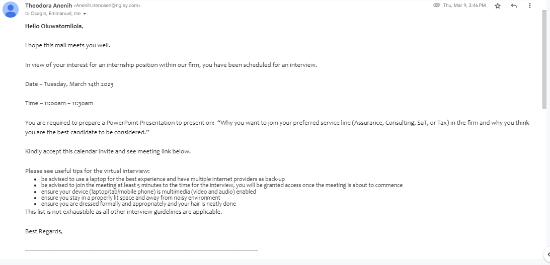

Figure 1.1: INVITE TO ASSESSMENT PARTICIPATION

During the interview, after I made my presentation, I was asked questions about my interests, and career plans and questions on some of my contributions in school and things I did while I went through some pressurizing moments in school. On the 23rd of March 2023, I received an offer letter from the company and a message from my onboarding guide welcoming me to the company. I resumed at the 10th and 13th floor UBA House, 57 Marina Road, and joined other interns and staff in the Welcome to EY (WTEY) Induction Program.

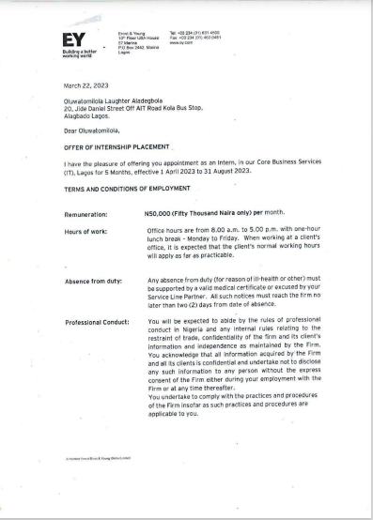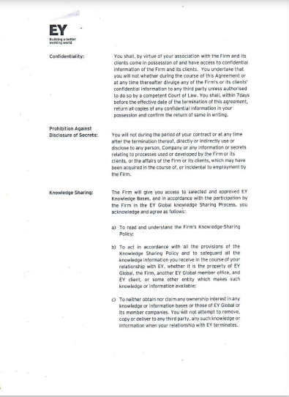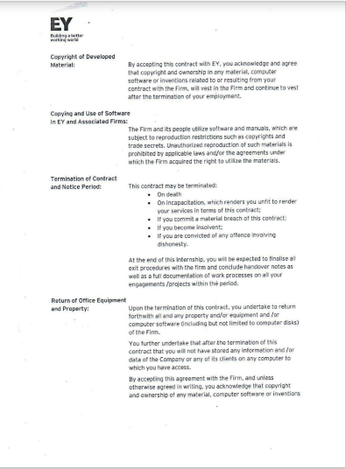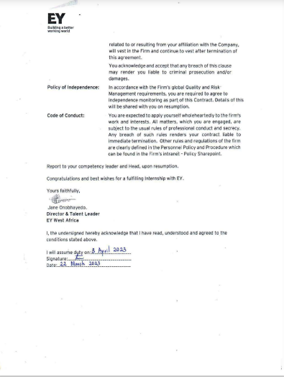

Figure 1.2: ERNST AND YOUNG’S ACCEPTANCE LETTER

## **1.3. INFORMATION CONCERNING THE COMPANY OF ENGAGEMENT**

### **1.3.1. ERNST AND YOUNG**

Ernst and Young is a British multinational whose headquarters is in London, United Kingdom and was founded in 1989 through a merger of Ernst & Whinney and Arthur Young & Co. and then given the name Ernst and Young but due to a rebranding campaign in 2013, the name was officially changed to EY which is now the trade name. EY is currently headed by Carmine Di Sibio, who assumed the global chairman and CEO position on 1st July 2019. It is a global firm in over 700 locations and more than 150 countries and an estimated number of almost 400,000 people worldwide leading in assurance, consulting, strategy, transactions, and tax services so it is often referred to as one of the Big Four consulting firms and was named the seventh largest privately owned organization in the United States in 2019 and has continuously been in the Fortune magazine’s list of the 100 best companies to work for the past 25 years which is longer than any other accounting firm.

The structure of Ernst and Young comprises both the Executive and Regions. Executive including global leadership, governance bodies, and the three geographic areas all working together to oversee global strategy, brand, business planning, investments, and priorities of the firm, there are 22 regions which are further categorized into the 3 geographical areas which include: the Americas; Europe, Middle East, India, and Africa which is known as EMEIA; and Asia-Pacific. This structure is to help streamline thereby allowing quick decisions, fast strategy execution, and providing clients with exceptional service around the world. I did my Industrial Training in EY’s Lagos branch located on the 10th and 13th floors of UBA House, 57 Marina Rd. Lagos Nigeria which is part of the EMEIA region.

Figure 1.3: ERNST AND YOUNG LOGO

### **1.3.2 PURPOSE- “WHY?”**

Ernst and Young has a driving purpose which is to *build a better working world.* That is providing great insights and quality services that help build trust and confidence in the capital market and the world’s economy. Building outstanding leaders who work together to deliver the promises of the firm to all the stakeholders and by doing this they fulfill a critical role in building a better working world for the people, clients, and communities.

### **1.3.3 AMBITION- “WHAT?”**

The ambition of EY is to create long-term value as the world’s most trusted and distinctive professional services organization.

These long-term values include:

* Client value
* People value
* Societal value
* Financial value

EY's Next Wave strategy was introduced in October 2019, and it focuses on delivering long-term value to all stakeholders it expanded the already established goal of creating financial value to also focus on creating values for EY people, clients, and society at large. This strategy is built on four pillars which include:

* Client centricity
* Exceptional and diverse people
* Data and technology
* Global integration and teaming.

So, EY Next Wave is the answer to “HOW” EY aims at creating long-term values.

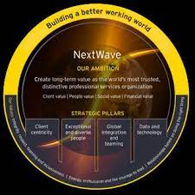

Figure 1.4: EY Next Wave Strategy logo

### **1.3.4 VALUES- “WHO”**

At Ernst and Young, it is believed that their values define who they are:

* **People who demonstrate integrity, respect, teaming, and inclusiveness (Diversity, equity, and inclusiveness):** This means that the diverse perspectives of people are combined with an inclusive culture and equal opportunities are provided to drive better decision-making, stimulate innovation, increase organization agility and strengthen resilience to disruption. The organization maximizes the power of all differences realizes the full potential of all employees minimizes blind spots and encourages innovative thinking to help deliver the long-term value of the organization in the global marketplace. As a global organization EY has the opportunity to address the impact of inequities and injustice to push for progress both within EY and beyond so they are committed to advancing social equity and inclusive growth and stand against injustice, bias, discrimination and bias for this EY has been awarded global equality standard (GES) recognition.
* **People with energy, enthusiasm, and the courage to lead:** At EY, they believe they must act responsibly in the long-term interests of shareholders which is guided by their purpose of building a better working world. So, they are proud participants in the United Nations Global Compact (UNGC) so the global organization is committed to advancing the Sustainable Development Goals(SDGs) and to aligning their strategy and operations with the UNGC Ten Principles and they do this through the “EY Ripples Program” where the EY people are devoted their time to SDG-focused projects bringing together the combined skills, knowledge, and experience of the global EY network in pursuit of the EY vision.
* **People who build relationships by doing the right thing:** EY is focused on broadening access to future-focused skills so programs such as the EY Future Skills workshops have been revolutionized in response to the COVID-19 pandemic with the introduction of virtual delivery to make vital knowledge more accessible to all and help young people build skills that are adaptable, critical and relevant to a changing working world. So they have partnered with non-profits and other organizations to help deliver content to teachers and students making it accessible to all.

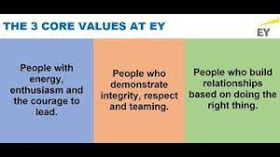

Figure 1.5: EY’s Core Values

### **1.3.4 ORGANOGRAM**

There are 5 main departments as referred to “service lines” at Ernst and Young four of these service lines are a client that is the members of these service lines deal with the clients directly while the fifth is not client-facing they include: Assurance, Consulting, Tax, Strategy, and Transactions (SAT) and Core Business Services(CBS).

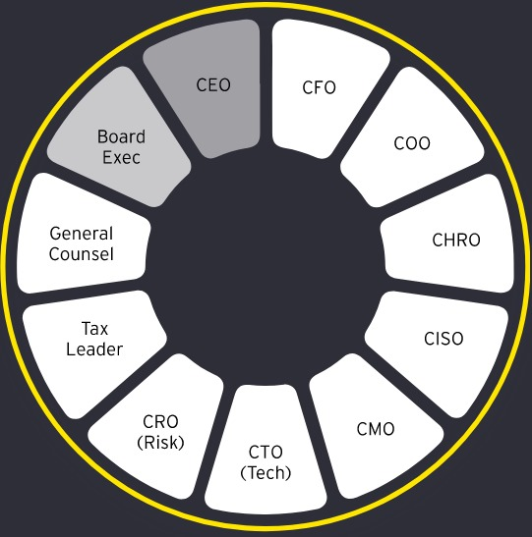

Figure 1.6: EY’s Organogram

* **Assurance-** Assurance teams serve the public interest by promoting trust and confidence in business and the capital markets so their services include: Audit, Financial Accounting Advisory Services (FAAS), CCaSS (Climate Change and Sustainability services), and Forensic and Integrity Services.

Audit teams serve the public interest by delivering high-quality, analytics-driven audits with independence, integrity, objectivity, and professional skepticism.

FAAS and Forensics team are responsible for protecting and restoring the enterprise and financial reputations and supporting the finance function in enhancing decision-making and efficiency and addressing risks and opportunities that arise from climate change and sustainability issues.

* **Consulting:** Consulting teams are responsible for realizing business transformation through the power of people, technology, and innovation. These service lines are further divided into: Business Consulting, Technology Consulting, and People Advisory Services.
* **Tax:** Tax teams are responsible for providing services across all tax disciplines to help clients thrive. Services such as Transfer Pricing, International Tax Services, Business Tax Compliance, Global Trade, Indirect Tax, Tax Accounting, Risk Advisory Services, Tax Technology and Transformation, and Transaction Tax.
* **Strategy and Transactions (SAT):** Strategy and transactions teams are responsible for helping clients navigate complexity by reimaging their eco-systems, reshaping their portfolios, and reinventing themselves for a better future. They help clients navigate downturns and position them for recovery through corporate strategy and transactions, Mergers and Acquisitions (M&A), and divestments. They are responsible for dealing with the transformation of companies’ capital which includes Valuation, Modelling and economics (VME), transactions due diligence, real estate advisory, merger and acquisition (M&A), Turnaround and restructuring (financial and operational), and Corporate Finance.
* **Core Business Services:** This service line is not client-facing that is, does not interact with the clients. So, it comprises the Market Team, Risk, Talent Team (HR), and Operations. They are responsible for business development, marketing, legal, and risk management.

### **1.3.6 COMPANY SERVICES**

EY is dedicated to helping organizations solve their toughest challenges and realize their greatest ambitions from start-ups to Fortune 500 companies through their major four service lines- Assurance, Consulting, Strategy and Transactions, and Tax they help clients capitalize on transformative opportunities to help them fulfill regulatory requirements, keep investors informed and meet the needs of stakeholders so they provide the support companies need to be effective today and create long-term value tomorrow. EY has significantly changed its business approach to offer a wider range of services due to the growing competition in the existing and new market of professional services.

The services include:

* **Assurance**: They provide assurance services to companies to help instill trust and confidence in the public through their services, reputations, and finances.
* **Consulting:** They provide consulting services to organizations to ensure that through their people, technology, and innovation they are driving toward business transformation.
* **Strategy and transactions:** EY provides this service to help clientsreposition themselves for a better future by navigating through complexity.
* **Tax:** EY provides tax services to organizations to ensure that irrespective of the tax discipline they thrive.

### **1.3.7. INTERNSHIP POLICY**

The EY internship program is open to undergraduates, MBAs, or advanced-degree students. They offer both summer and winter internships to help provide experiences, relationships, and learning and development opportunities to help launch your EY career.

Interning in a service line helps you gain exposure to the business at EY and the world-class clients under the guidance and coaching of the professionals at EY and gain experience while working on projects such as presenting and networking while also learning how to care for your physical, emotional, social and financial well-being and receive feedback, guidance, and coaching from EY professionals to help you develop the skills needed to succeed.

Some of these professionals include Buddy and a counsellor which everyone is entitled to upon resumption. EY buddy is a person who is either within your team or department and supports a new joiner during the first few weeks and months to enable them to adapt and settle fast.

## **1.4. SUBMISSION OF NECESSARY LETTERS**

## **1.4.1 SUBMISSION OF ACCEPTANCE LETTER TO COVENANT UNIVERSITY**

Alongside the mail that was sent to me by the talent team was an offer letter that explained in detail the duration of the internship, the terms, and conditions of employment, expected code of conduct, annual salary, and expected working hours. I signed the acceptance letter and scanned a signed copy back to the talent team.

I promptly forwarded the signed copy to the Covenant University siwes email address [siwes@covenantuniversity.edu.ng](mailto:siwes@covenantuniversity.edu.ng) on the 24th of March 2023.

### **1.4.2 SUBMISSION OF STUDENTS COMMENCEMENT OF ATTACHMENT FORM(SCAF) TO INDUSTRIAL TRAINING FUND OFFICE**

Before the commencement of the SIWES program, I received a SIWES placement letter from my department alongside Form 8 and the students’ commencement of attachment form (SCAF).

A week after I resumed office after the Welcome to EY (WTEY) Induction Program I got the necessary signature and stamp needed to be able to submit the Students Commencement of Attachment Form (SCAF) to the nearest ITF office.

I submitted my Students Commencement of Attachment Form (SCAF) to the ITF officials in the ITF office located at Plot 20, Adeyemo Alakija Street, Victoria Island, Lagos on April 11th, 2023.

## **1.5. COMMENCEMENT OF INTERNSHIP**

My internship officially commenced on 3rd April 2023. Staff in the talent team- HR department gave me a warm welcome as I joined other interns and staff, and we began the onboarding session. The onboarding session lasted 1 week and was filled with various training sessions and activities from a session introducing us to EY, the founders, the vision, the values, the various departments, or as we refer to them “service lines”, to a welcome message from the CEO and other executive members to a session on the appropriate behaviours while we work within the office space and the office space of the clients, to a session on risk management and independence- the 10 principles, then a session on the various resources the company provides, their uses and importance and then finally a tour round the office space.

I was assigned to the Core business service (CBS) service line. So, throughout my internship, I was privileged to work with the EY Technology unit a unit under the CBS service line. I worked with the EY Technology team as an IT support member, so I provided technical support to staff and interns whether hardware or software.

On August 31st, 2023, I was assessed by my Covenant University Supervisor, Dr. Abatan Olubunmi from the Department of Chemical Engineering. During the assessment, she discussed with my supervisors where she asked questions concerning my performance, attitude to work, and growth level and asked for general and honest comments. My supervisors gave positive remarks concerning all her questions from my work ethic to my attitude to work and character. The faculty supervisor also inquired if the company is willing to accept more interns from Covenant University, and there was a positive response.

# **CHAPTER TWO**

## **2.1 FACILITIES AVAILABLE AT ERNST AND YOUNG NIGERIA**

At EY, I worked with facilities both hardware and software including:

1. **Laptops**: At EY everyone is given an official laptop before resumption the laptop is specifically set to provide resources that will assist you in carrying out your duties in your specific department these laptops vary depending on the department and the tasks you are required to perform. To assist me in carrying out my duties, I used DELL Latitude 5400 with specifications: Intel Core i7-8665U, 32GB Memory, 256GB PCIe M. 2 NVMe SSD, for all my official tasks.



Figure 2.1: Dell Latitude 5400

1. **Success Factors**: Success Factors is a personalized guide specific to everyone. It shows in detail your profile, and your learnings- learning paths and grants you access to various platforms for development. I used success factors to check progress on some of the learnings I was engaging in, I also used success factors to fill in my timesheet every week- a timesheet is an attendance you are expected to fill in every week which shows in detail your engagement code, engagement id and the number of hours spent on the work daily.
2. **Microsoft Teams**: I used Microsoft Teams regularly during my internship for communication to receive messages relating to work, communicate with other staff, and provide online support when needed I used Microsoft Teams often for meetings and trainings especially the end of the month interns training.

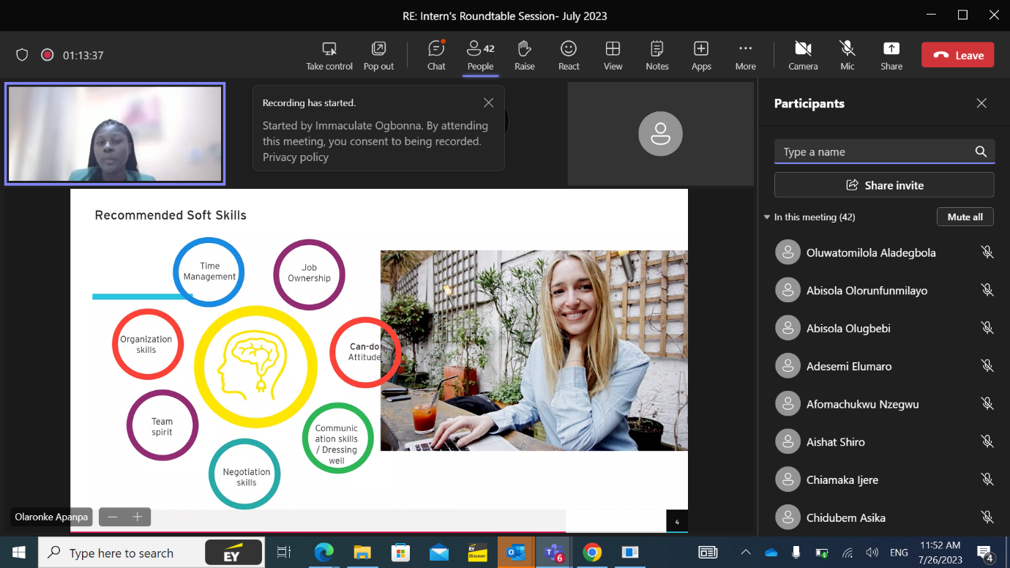

Figure 2.2: July Interns Roundtable Session with Microsoft Teams

1. **Microsoft Outlook**: I used Microsoft Outlook to send and receive important emails, and reminders relating to important physical or virtual meetings or events.



Figure 2.3: Microsoft Outlook

1. **Data**: Everyone is entitled to a monthly subscription plan which varies depending on your level. As an intern, I was entitled to 6Gb monthly to help me get my work done while I was not physically present in the office.
2. **Wi-Fi**: We had access to the company Wi-Fi whenever we were in the office. Our work laptops automatically connect to the Wi-Fi when we are within the office space. We also can grant Wi-Fi access to our mobile devices by creating an account through the website which we can only gain access to through our laptops.
3. **ID Card**: We each have individual ID cards which serve as a means of identification.
4. **Access Card**: We each have access to two access cards- one which is the UBA Access Card and the other is the EY Access Card. The UBA Access Card is given to us to gain access in and out of the main building- which is the UBA building and the EY Access Card is given to us to gain access in and out of the EY office floors- the access card is specifically assigned to everyone and it grants access to specific areas in the office this access is restricted or allowed depending on your unit and department.
5. **Break Room**: There are a total of 3 break rooms on each of the two floors we use for our office space these 3 rooms are all for different purposes. On each of the two floors

we use for our office space; we have one pause room each. The pause room is a room where you take a break from work rest and eat- laptops are not allowed and work-related activities are banned from the room. We also have the prayer room- the prayer room is a room designated specifically for prayer sessions. Then the last room is a room for visitors/ guests- that is where the drivers of staffs are allowed to stay while they wait during work hours. There is also the kitchen which has a microwave, water dispenser, sink, plates and cups, a fridge for storing food and drinks, and a sink for washing plates after eating.

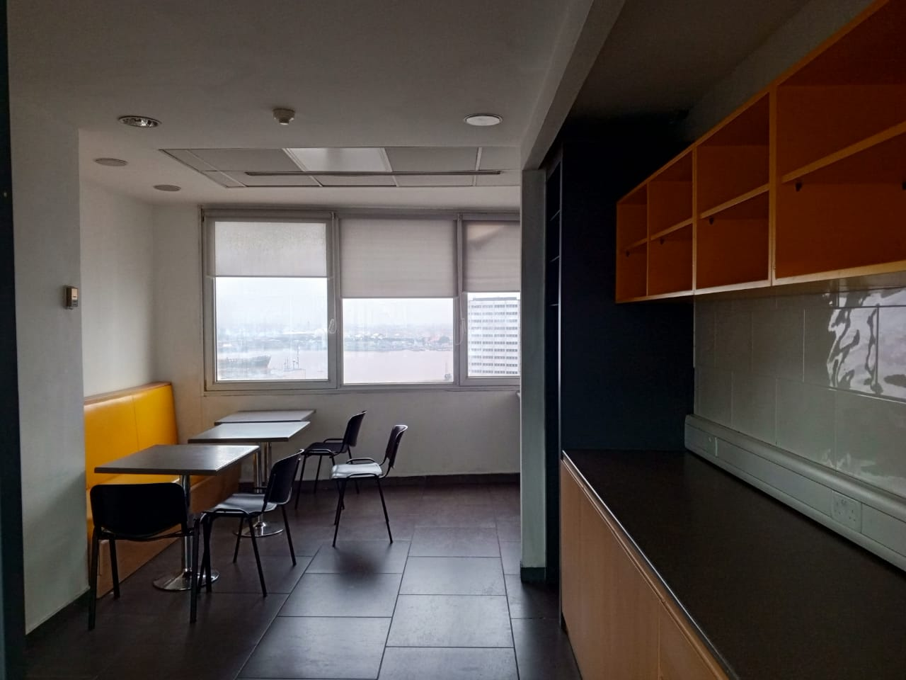

Figure 2.4: EY’S Break Room

1. **Workspace**- We use two floors in the UBA building for our activities- the 10th and 13th floors. The 10th floor is designated for the members of the Consulting, and Tax service lines- there are also members of the CBS service line present there. The 13th floor is designated specially for the Assurance service line due to the large number of staffs present in that unit then the SAT service line also but they occupy a small space on the floor.

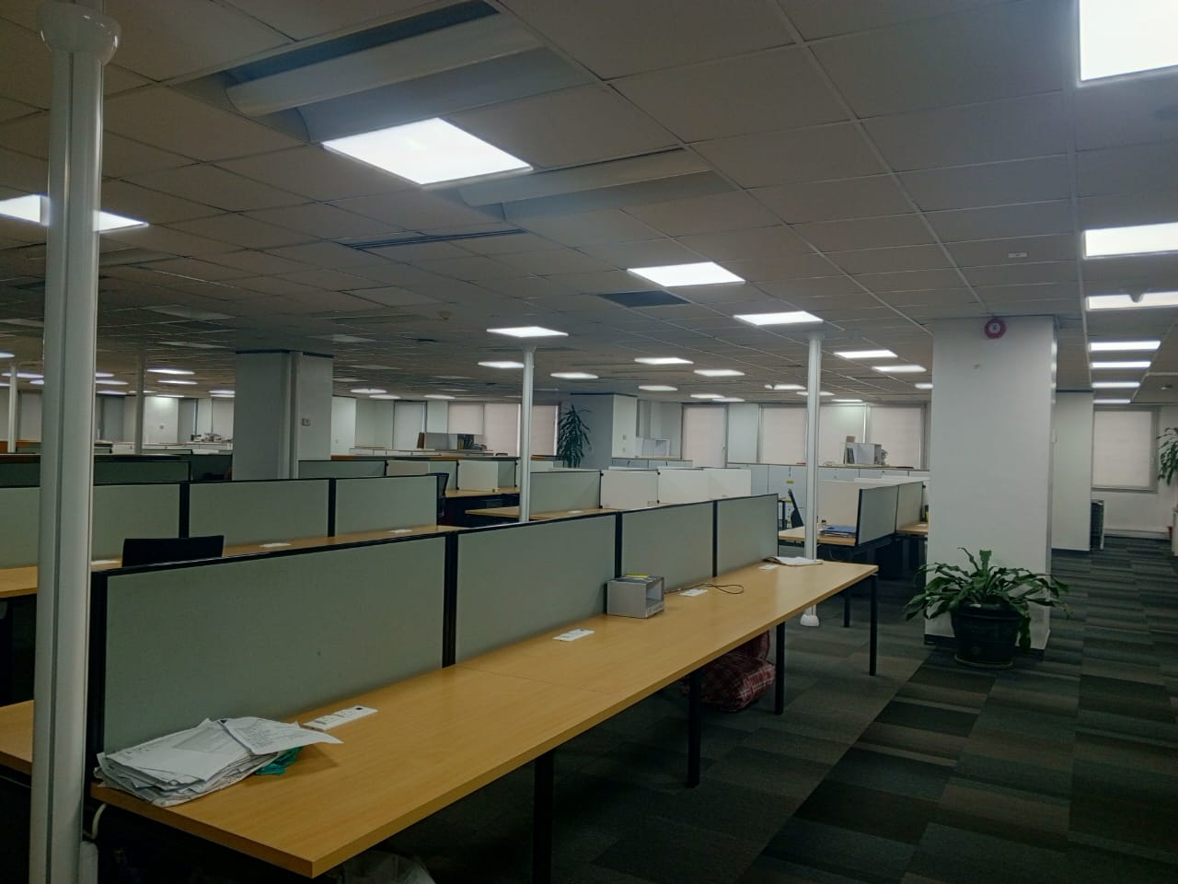

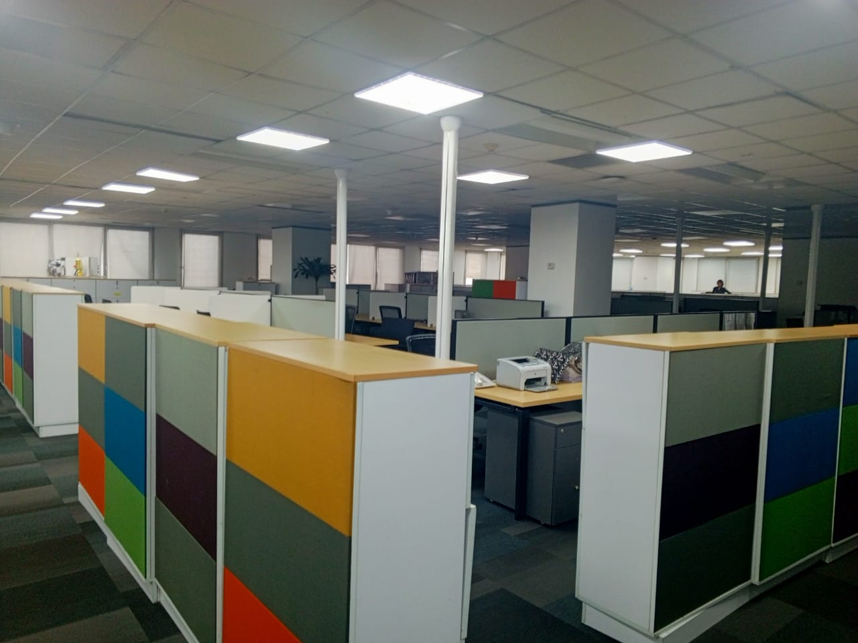

Figure 2.5: EY’S Workspace

1. **Meeting room-** On each floor, we have the meeting room where physical meetings, and meetings with clients- either physical or virtual held.

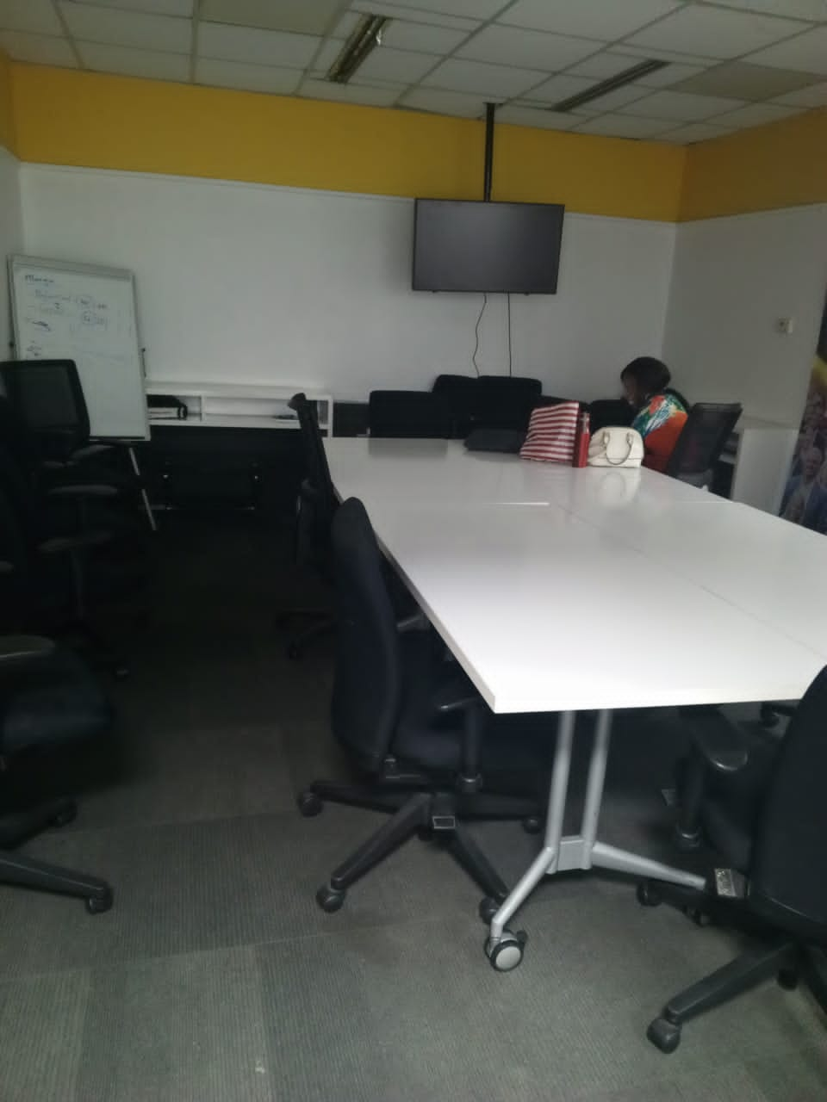

Figure 2.6: EY’s Meeting Room

1. **Udemy:** This is a learning platform that provides access to various online courses to grow professionally and personally. At EY, all members of the organization are provided access to this platform using their registered EY email address upon resuming into the organization and it is only valid for use throughout your contract.



Figure 2.7: Udemy Logo

1. **PingID:** PingID is a cloud-based strong authentication solution that allows users to authenticate to applications via their phone. Due to the nature of work at EY being mostly remote PingID grants access to the company’s resources that you can only have access to while being connected to the company’s network.



Figure 2.8: PingID Logo

1. **Tech Help:** EY tech help is a technical support system designed to help with technical issues when they arise. It contains in details various issues and provides answers in detail on how to go about these issues. So, tech help acts as the first support system when you can not connect to the IT team.
2. **Owl Camera:** This is a video conferencing camera that provides 360o view to keep everyone in sight. At EY, the owl camera is used during meetings to connect remote team members connected online with onsite employees to deliver an immersive experience and allow natural conversations.



Figure 2.9: Owl Camera

1. **Cisco PolyConference Phone:** The Cisco PolyConference Phone is used especially in the board room to make communication easy and allow collaboration with clients, and colleagues during meetings it is useful because it allows 360-degree coverage so everyone present during the meeting can be heard clearly.



Figure 2.10: Cisco PolyConference Phone

1. **Integrated Development Environments (IDE):** These are applications used primarily for software development to help develop software code efficiently. I worked with IDEs including R Studio, and Jupyter Notebook while taking courses on Udemy at EY.

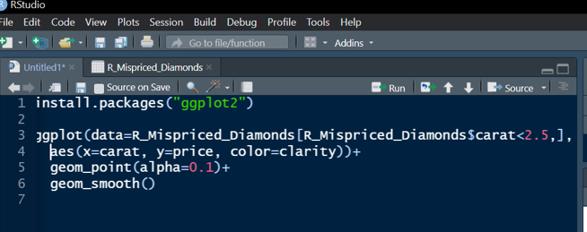

Figure 2.11: R Studio

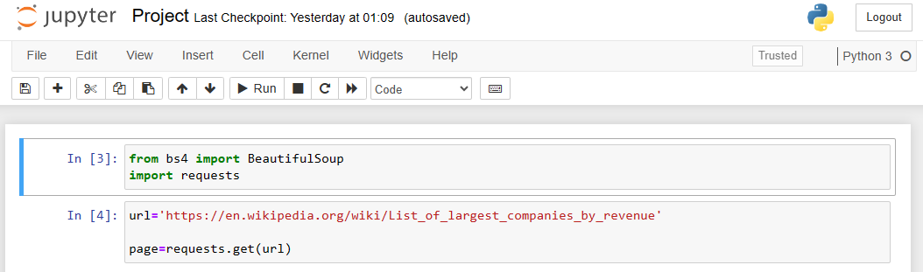

Figure 2.12: Jupyter Notebook

1. **Microsoft Excel:** I used Microsoft Excel during one of my training sessions at EY to learn new formulas and functions. I also used it for data analysis and manipulation of data for a project I worked on for one of my learnings.

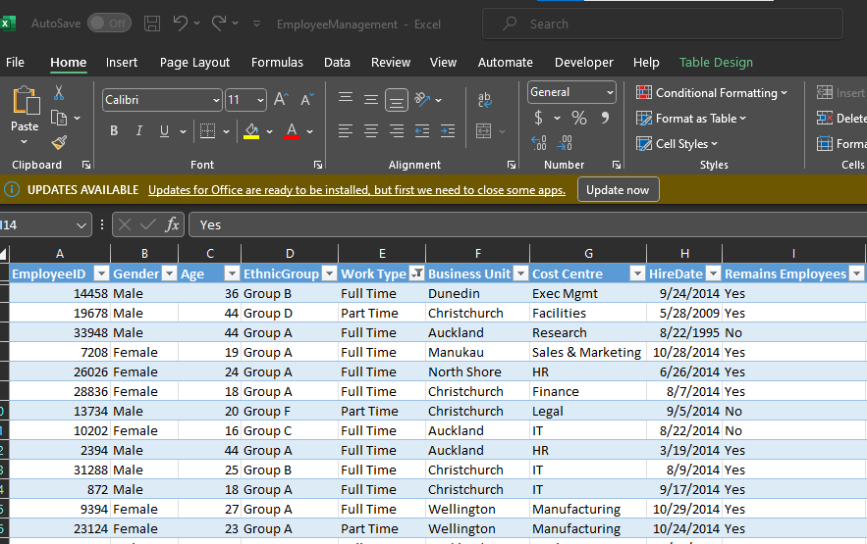

Figure 2.13: Microsoft Excel

1. **Power BI:** During my internship, I started a course on PowerBI and used PowerBI for data visualization mainly to produce interactive insights from data.

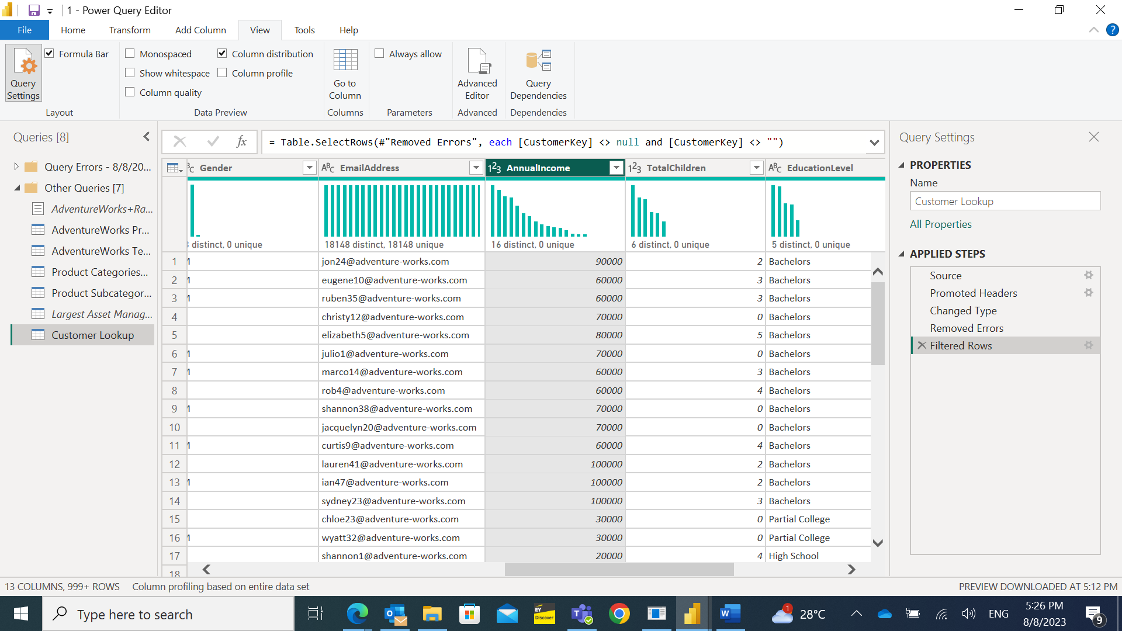

Figure 2.14: Power BI

1. **Tableau**: During my internship, I learnt how to use this tool for data visualization .

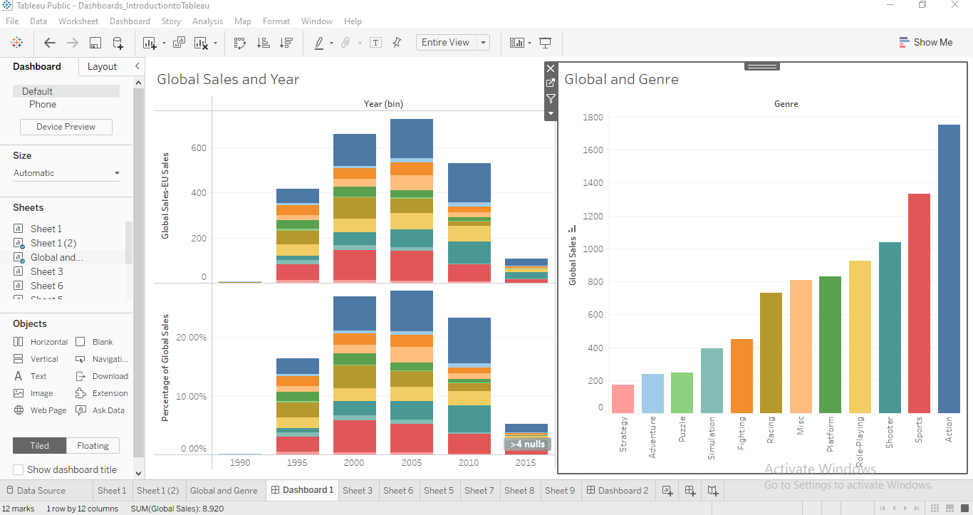

Figure 2.15: Tableau

## **2.2** **QUALITY OF WORK FROM COMPANY-BASED SUPERVISOR**

I owe the success of my internship to the quality of supervision I got all through the period of my internship not only from my colleagues or my supervisors but also from other professionals across different units who showed me and exposed me to various skills. I was assigned a supervisor Mr. Felix Damissah although, I reported to three other staff members in the EY technology team during the period of my internship.

My supervisor, Mr. Felix Damissah a senior associate was a very fun, loving person he carried me along in every process or task I was to undertake. He was easily approachable, and I could meet him if I needed clarifications on things or support when I could not carry out a task well. He asked me about my other interests and was very supportive by giving me advice regularly career-wise on the necessary skills to build and encouraging me to take advantage of the platforms provided by the organization.

The associate who oversaw all my activities asked me from the first day I joined what kind of career path I would like to follow- he supported me by giving me advice on what skills to develop, introducing me to various learning platforms, and asking me frequently what projects I worked on, how far I had gone with my learnings.

I had a fun, exciting and inspiring time working under this unit throughout my internship they were all very attentive, supportive, loving, and caring and never failed to encourage me even when I needed support. Overall, the supervisory skills displayed by everyone were the best.

**2.3 KNOWLEDGE GAINED WITHIN PERIOD OF INTERNSHIP**I gained a lot of experience during my internship program from my interactions with my colleagues/ team members to complete a task and even to interact with members of other units while providing support to them and attending to their issues which played a big role in how I got work done.

### **2.3.1 WORK DONE AND KNOWLEDGE GAINED**

During my industrial training, these are the tasks I carried out with the support and supervision of my team members and the knowledge I gained while performing the tasks:

* **Onboarding and Offboarding:** As part of my responsibilities, I oversaw assigning and retrieving work tools, such as access cards and laptops, to staff and interns. This process required me to reload the operating system, wipe the disk to delete the previous user's information, and set up company resources on the system. I also had to give elevation rights to the user to provide more access to some resources. Furthermore, I had to record the details of the users and the work tools to track their usage effectively.
* **Technical support:** During my time at EY, I gained valuable experience in providing technical support both hardware and software. I developed the ability to identify computer issues and effectively troubleshoot them, including replacing malfunctioning hardware components.
* **Ticket Resolution:** During my time at EY, I was responsible for managing the creation, tracking, and resolution of ticket issues. The essence of creating these tickets was to provide efficient support either locally or globally to users experiencing hardware or software difficulties that impacted day-to-day operations. As part of this process, each ticket generated was assigned a unique ID that was sent to my supervisors for verification and closure once resolved. These ticket IDs were also used to track performance and served as our KPIs.
* **Meeting Rooms setup:** I helped in setting up the meeting rooms for audiovisual meetings held in the office. Setting up audiovisual devices such as the projector, the owl camera, the speakers, and the microphones in the meeting rooms making sure the room was ready for meetings to be held and everyone was comfortable by setting up extension boxes so everyone’s laptops remained charged throughout the meeting.
* **Laptop Age Mitigation Policy:** At EY the devices are to be changed after at least four years of use. So, in 2023 during my internship new laptops were procured so my team was given the task of:
* Identifying all the newly procured laptops- by taking down the serial numbers so that the laptops can be tracked when replaced.
* Replacing laptops for staff members with laptop models procured before or in the year 2019.
* Building the new laptops- by providing the resources needed by each staff specific to their department and syncing all their files saved on OneDrive to the new system making sure all their files and emails were available on the new systems.
* **Routine assets check**: My team, and I were tasked with doing a routine check on the conditions of some of the hardware present in the office to make sure that they were running well for the day.
* **Asset Documentation:** The unit had a lot of laptops in the storage- laptops passed warranty, and laptops with faults so my unit was responsible for the documentation of those laptops- which involved identifying the faults of the laptops, the disposal of the laptops and sorting laptops whose parts could still be used to replace the parts of other laptops when users come to complain about them. In doing this I was able to apply my existing knowledge of Microsoft Excel to assist my team in making sure that there were no duplicate values when we all merged our documentation.

### **2.3.2 TECHNICAL SKILLS GAINED**

* **Computer Repairs:** During my internship, I gained extensive knowledge about computer repairs, an area that I had never experienced before. I was taught how to identify issues with laptops, troubleshoot, and fix the issues- issues either with the hardware or the software and sometimes network issues. Through this experience, I developed a full understanding of the importance of properly maintaining laptops to prevent severe damage and keep them in good condition.
* **Introduction to Data Analysis and Visualization:** In my department, it was advised that all interns were required to take advantage of the learning platforms provided by the company to learn some aspects of tech we were interested in. So due to my interest in data analytics, I deepened my understanding of working with Microsoft Excel for data analysis. So, I worked with Excel and learned a lot about functions such as SUMIF, INDEX, VLOOKUP ..., data visualization with Excel, Tableau, and PowerBI, and how to clean data, analyze data, and transform data with Excel.
* **Programming:** I took advantage of the learning platform provided and did a course on R programming. I learned about visualization with R and worked with various libraries such as ggplot, I also learned more about data frames, functions, and matrices and got certified in R programming on Udemy. I also learnt the basics on cleaning data with python with the use of the pandas library.
* **Web Scraping with Python:** As someone who is looking into pursuing a career in data science learning a bit on web scraping was a good idea for me. Data scientists are known to always work with data and derive insights from these data, so web scraping is a method used by data scientists to gather the data that they need to work with. During my internship I made use of libraries such as Beautiful Soup, and Pandas ... used functions such as find, find all, and understood the difference between these functions.

### **2.3.3 SOFT SKILLS GAINED**

* **Communication Skills:** I got to understand and value the importance of communication in the workplace through consistent interactions with my colleagues within my department and other departments too. I got to embrace the importance of tone in conversations especially when I had to send emails or messages to team members or supervisors of my department or other departments.
* **Teamwork and Team Building:** As someone who is used to doing things by myself, I got to understand the importance of work delegation to make sure no one was left out and understood that it is okay to receive support from other team members and how doing these things help build a better relationship within the team.
* **Networking:** I learned the skill of opening up to people and making connections, especially with people who have similar interest in what I do and are working in the field I am interested in. I learned how valuable this skill is in the workplace.
* **Leadership skill:** I learned how to lead especially when my colleagues were not around, I had to take up the responsibility of getting things done and delegating tasks to other people. I was also opportune to lead a new intern by showing him the work we do and helping him settle into the work well which was a new and good experience for me as I learned a lot about leadership- the importance of work delegation and trusting the people you assign the tasks to do the job.
* **Self-esteem and confidence:** I had to build confidence while I worked daily as I realized how important it was. I realized that since I was an intern and didn’t have experience, especially in the workplace I had to exhibit confidence so that whoever I was providing support to would also be confident in whatever I do and trust me to handle the task.
* **Adaptability:** I learned how to adapt to the new skills I was required to learn, to the environment and whatever situation I was faced with, and to make sure that I do my best in everything.

### **2.3.4 TRAININGS AND CERTIFICATIONS COMPLETED**

Apart from the skills I gained, I was able to complete some training sessions a lot which were held by staff of the company, and some were mandatory courses that required me to understand the nature of the work done by the company better and some of these mandatory learnings/training were certified. These trainings include:

* Becoming a valuable team member
* Microsoft Excel
* Security Awareness
* Data Protection Fundamentals
* Financial Crime
* Global Code of Conduct
* R programming

# **CHAPTER THREE:**

## **3.1 APPLICATION OF KNOWLEDGE GAINED**

### **3.1.1 APPLICATION OF KNOWLEDGE GAINED TO THE FIELD OF STUDY**

Thanks to my industrial training at EY in the last few months I have been exposed more to Data Analytics an area I am particularly interested in pursuing as I was able to gain knowledge on data visualizations with Excel, tableau, and some parts of PowerBI, data cleaning with excel and programming with R and Python. I was privileged to work with datasets and apply some of the things I learned to this dataset and derive insights from them.

I also gained more knowledge on Hardware and Software support- hardware repairs which I believe would be an added knowledge for me as I could detect issues with my laptop myself and provide support to myself to an extent.

### **3.1.2 APPLICATION OF KNOWLEDGE GAINED TO EY’S GOALS**

A goal of Ernst and Young is to build a better working world starting with becoming a “better me” so I believe that by going the extra mile of going out of my regular work duty and taking full advantage of the resources provided by them I have contributed to their mission and goal. Taking courses on Data Science or Analytics also a leading career in the technology industry today, I believe I have contributed to the EY goal focused on broadening access to future skills that are relevant and critical to this changing world for young people. Thanks to all of the technical skills, regular monthly training, and soft skills I believe that I have successfully fulfilled EY goals and I have been able to launch my career in the world today and even at EY.

### **3.1.3 APPLICATION OF KNOWLEDGE GAINED IN THE LARGER SOCIETY.**

Right now, technology is viewed as the future with more and more data being produced today the demand for data scientists has been on the rise. According to the US Bureau of Labour data scientist jobs are predicted to experience 36% growth between 2021 and 2031 so I believe with the skills I have gained during my SIWES program and advice I have received from other data scientists at EY during my industrial training I have gained insights into building a successful career and I believe that I can make an impact wherever I am. I also gained a lot of soft skills such as teamwork, networking, communication, and adaptability which I believe will be required in my future endeavours and even impact my career more making me valuable in any company or industry I work in.

### **3.1.4 CORROBORATION/NEGATION WITH KNOWLEDGE ON CAMPUS**

During my industrial training, I was exposed to a lot of experiences that helped me understand the differences between the academic setting and the real world, and for some experiences, I was able to appreciate and understand the importance of the knowledge gained on campus as it prepared me.

1. **Web Scraping with Python:** Due to the basic knowledge I got of Python in a course did in 200 level - CSC 211, I was able to understand some of the basics while I started learning on Web Scraping but I will say that I did struggle especially while I was working with some of the libraries as they were all new to me so I had to take the extra mile of understanding more by doing more research on various lines of code. I then finally understood that there is more to programming than the basics we did in school and realized that the curriculum is not comprehensive enough to qualify yourself as a programmer as one needs to take extra steps.
2. **R programming:** I did an elective course in 300 level CIS 319-Statistical Methods and in the course, we explored R programming. So, while I was taking the R course, I could understand some of the things I was being taught but I realized that a lot of the things I did while I did the course in school was cramming and not fully understanding the reasons why some of the codes were written and I didn’t have a complete understanding on some of the functions used.
3. **Computer Repair:** Although computer repair is not in the curriculum as something you learn in class. I did find some of the knowledge I gained in CSC 125 (Operating System I ) useful as I realized that a lot of the things I was taught majorly about parts of a computer, the importance of taking care of certain parts of the computer in some ways and how those parts can be damaged were being applied during my internship. So, I was applying all my theoretical knowledge while engaging in hands-on practicals this made things clearer on what I had learned in class.
4. **Data Analysis:** Although data analysis is not in the curriculum it is nice that a lot of the things, I learned in class were applied in this area . I also was able to apply a lot of the knowledge I gained from the Data Science Club in the department. I understand that this area cannot be fully integrated into the curriculum, but it is beautiful that the institution recognizes this skill as important and makes it an option for the EDS practical and that there is a club handling this responsibility within the department. I believe the department could consider looking into the club, making the training more consistent, and supporting the club by providing people to train the students and working with the club executives to provide publicity thereby creating more awareness in school and encouraging more students to join.

### **3.1.5 WORK CULTURE IN THE ORGANIZATION AND ITS IMPORTANCE IN ITS GOAL ATTAINMENT AND CULTURE SHOCK**

At EY one major culture shock during my experience was how casual everyone is at work. That is, regardless of age and rank everyone was mandated to address one another by their first names without titles. It was difficult to adapt to this as I have had to address people especially older than me with titles all my life. There were times when unconsciously I added titles while referring to colleagues at work and they asked me to address them by their names alone but I finally adjusted and had to learn to since that was the work culture.

I was shocked by the diversity at EY, there were people who had different religious beliefs, and people who came from different cultures regardless of this everyone was appreciated -there was a room specifically for the Muslims to pray on the 13th floor and on the 10th floor the Christians were allowed to have the mid-week gathering there, I even saw the Buddhists statues on some of the desks. There was no discrimination at all, and everyone was appreciated equally. So, during my stay at EY I learned to appreciate everyone regardless of their religious beliefs and cultures and treat everyone equally.

Another culture shock would probably be the events despite being an international firm with people from various countries working there, I was shocked to see that the company regularly celebrated everyone when there was an event relating to their culture. I was able to experience one of the events which was the EY Africa day which was fun, we had to dress to work in our native attires, Nigerian food was served in the office that day, the office was decorated with some touch of traditional designs- things peculiar to the ancient times, we were invited to the party in a special way- some of the talent team staff came into the office workspace playing the talking drum and going round to call people just like town criers did in the ancient times, we danced to songs from different cultures and tribes represented in the office, we played games and took pictures it was amazing.

It was also surprising and nice to see how the company was involved in the growth of everyone even for the interns as there were opportunities for interns to build experience as the company provided training monthly to the interns which was headed by other staff members, managers. The talent team asked regularly in everyone was handling projects to make sure that all hands were on deck. The staff members were easy to approach and communicate with when I needed clarification on some tasks, and they were so encouraging too even when I didn’t do things well.

I also loved how friendly the meeting environments were there was time to learn, time to play games, and time to take breaks. I was majorly shocked by this during my induction and one of the end of the month interns roundtable training, the induction lasted for a week and each day we had a lot to cover despite this there were break times when we would play games and sometimes compete for prices and during the tea break tea was served alongside snacks.

## **3.2 CHALLENGES FACED.**

During my internship, I was faced with various challenges, but I was able to overcome most of them thanks to the support of my colleagues, and supervisors, and the advice I regularly received from other staff and interns.

The challenges include:

* **Securing a placement:** The process of getting a placement at EY was not easy first I needed a referral after I got the referral I was not contacted immediately since it was not during their recruitment season and once I was contacted I had to go through various interviews, tests, and even create a presentation to present to the panel to determine whether I was qualified or not which is another reason why I did not start early due to the process I had to undergo to secure the placement.
* **Settling into my daily activity:** Computer repairs is a part of tech I know nothing about, so it wasn’t easy for me when I started a lot of it was a new experience. I struggled with even holding a screwdriver as it was a first for me, I couldn’t even open a laptop and I had to understand the various parts of a laptop which I was used to just seeing on the screen in class or a textbook as I have seen in school. Since I had no experience in this area, I had to reach out to my colleagues regularly for support and I did more research personally by taking advantage of online resources to learn more about this area.
* **Working under pressure:** There were times when we had a lot of work to do and had to make sure that everyone was attended to which was difficult as I tend to panic a lot under pressure. I had to reach out to my supervisors because it seemed like they were always calm in those situations and there I learned something my supervisor calls “People Management” which is how to manage people’s issues in such a way that they do not get offended and he also taught me to try to stay calm and not show how tensed I was while dealing with them and just keep a calm and confident look while I attended to them.
* **Self-Confidence:** There were times when I felt incapable especially when I was unable to support people or when I didn’t do things well but thanks to my supervisors and colleagues I was able to overcome this as they guided me on what to do when I was in those situations and they helped me understand that it is okay to always ask for help from my colleagues when I needed it. I also was encouraged by some of the staff members whenever I was helping them as they were so encouraging, especially with their words, they were so nice and made sure to give positive remarks whenever I helped them or even if I referred them to my supervisors.
* **Time Management:** I struggled a lot with time management as there were times when the workload could be excessive causing me to leave late which could mean that I had to do some of the learnings late into the night or even work during the weekends.

## **3.3. PROJECT IDENTIFIED FOR THE STUDY**

* During my internship and as I learned more about data analysis and data science, I had to apply some of the things I had learned and took on a project. The project was on employee retention and compensation management.

The requirements of the project include providing insights on:

* the current employee status by determining the attrition rate, turnover rate, average salary, and gender distribution.
* the leave balance variation by department
* the attrition rate across business units
* the salary distribution across departments, and
* Determining the correlation between salary payout and employee age groups.

So, for this project after getting the data, I cleaned the data by ensuring the columns had consistent formatting, checking the spellings of words and making sure they were consistent, checking and removing leading or trailing spaces and using filter where necessary. I created pivot tables which helped me summarize the tables and get the specific information which I needed. After, I created charts from the pivot tables and organized them and then added slicer such that the charts change depending on the option selected in the slicer. For all this I used Microsoft Excel from start to finish.

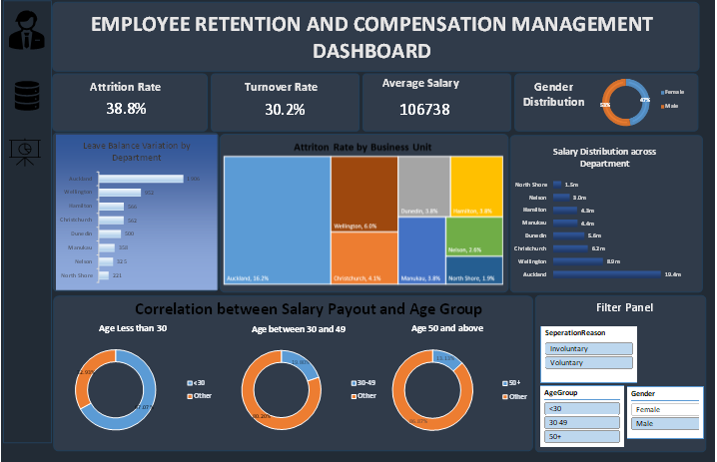

Figure 3.1: Employee Retention and Compensation Management Dashboard with Excel

After working with Microsoft Excel for this project I then tried using PowerBI to also visualize some of these requirements and created custom columns where necessary.

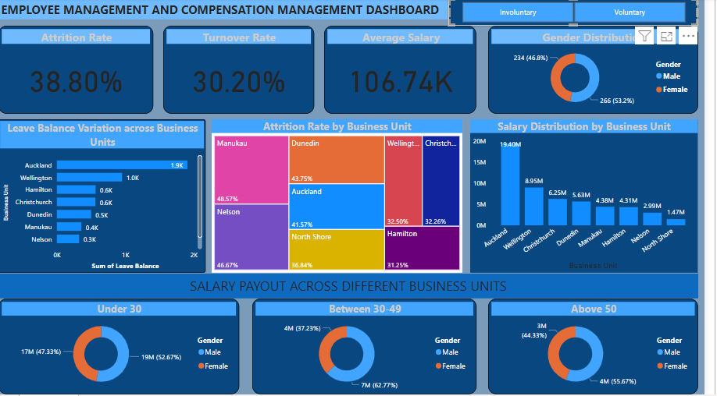

Figure 3.2: Employee Management and Compensation Management Dashboard with PowerBI

* **Web Scraping**: I did a project on web scraping which was extracting data stored in a table from a website- the data contained the list of the top 50 companies in the USA based on their revenue. I used Python and worked with the BeautifulSoup library to make this work and after extracting the data I created a CSV file to store the information extracted.

**Code:**

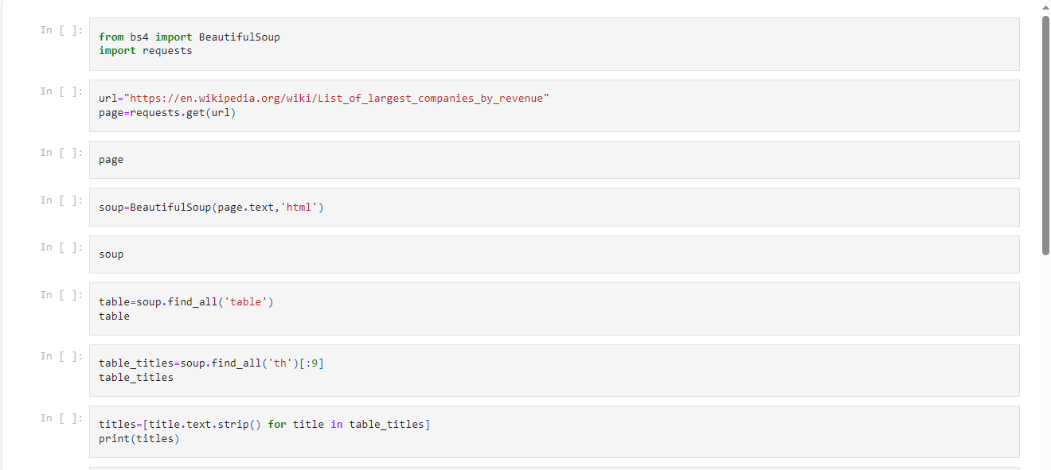

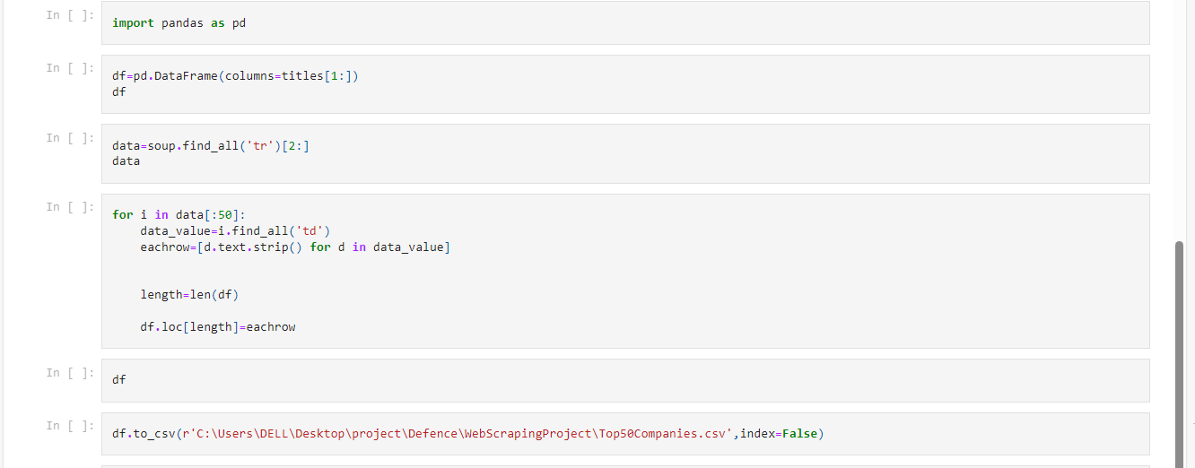

Figure 3.3: Web Scraping Project

# **CHAPTER FOUR:**

## **4.1. CONCLUSIONS**

My industrial training experience overall was amazing an eye-opening experience that would forever live in my memories forever and impact my life in so many ways.

I became mature in so many areas in the way I think, the way I act, and the things I do. I had to learn how to communicate well with people younger and older making sure that I spoke the right things to them. I learned how important it is to be myself which had a lot of influence on my work life as I got feedback from a lot of people that I had a lot of influence on people which made me realize how important it is to be myself no matter where I am. I also learned that it is okay to accept new experiences and it is good to take responsibility and do your best wherever you find yourself. Give it your best!

I got the experience of what the corporate world is like from meeting deadlines to attending meetings, to working under pressure and then doing activities that help increase your performance. I learned how to interact with people and the importance of networking in the workspace.

I fully understood the importance of SIWES as I was able to gain insights into corporate life and I would say that my mind has opened to more opportunities and my mindset is in a better place than when I started. It was an impactful and necessary experience I must say.

## **4.2. OBSERVATIONS**

* **Good Communication:** At EY, I found it easy to approach people, communicate, and contribute because everyone was attentive, and I felt like my contributions were of value.
* **Development Focused:** During my internship, I realized how driven EY is at helping employees become better in whatever career they choose to pursue. Regularly even as an intern, meetings were held at the end of the month to provide training either on technical skills or soft skills. EY also provides access to Udemy which is already paid for and EY badges which is accessible through your EY email address. Their desire to see everyone develop and grow fulfills their vision of building a better working world by first investing in building the staff members to be better.
* **Good Team Spirit:** During my internship, I felt like I was with my family because there was unity between my team and I so I could rely on them and receive support from them whenever I needed help so it felt like I could handle anything because I had an amazing team. We bonded over the smallest things such as showing interest in other people’s interests, celebrating ourselves for small accomplishments, and dealing with issues together.
* **Work Recognition:** At EY beyond my team alone I realized that a lot of times I received emails celebrating people either for promotion, completion of EY badges, winning the Tech MBA opportunity, winning a competition, and generally for great accomplishments of people even beyond the EY in Nigeria to encourage them after working hard. This was so nice as it even encouraged me as I saw people thriving in so many areas thereby making me more ambitious. Within my team, I received a lot of praise whenever I did things which motivated me constantly to be better.
* **Positive Work Environment:** During my internship, I observed a highly positive work environment that allows personal and professional growth. The leaders and staff radiated positive energy and were constantly encouraging and supportive.
* **Great Leadership:** During my time at EY, I had the privilege of encountering several inspiring leaders, particularly in delegation and trust. They were all approachable and supportive, even when I needed clarification or assistance. Their encouragement and ability to bring people together was commendable. Additionally, I appreciated how they corrected mistakes in private and supported me even when I attempted.

## **4.3. RECOMMENDATIONS**

* **Work-Life Balance:** If anything, I noticed and wish the company would improve in striking a work-life balance I was opportune to meet people from various departments and I noticed that there were times people would complain about not having time for themselves due to the constant workload, the pressure to meet deadlines constantly, attend meetings with clients regularly. I then realized that if it is possible the firm could try to figure something out to help employees gain experiences outside of work and have time for themselves, especially during the weekend.